

**Department of Computer Engineering, PICT Pune** Third Year Computer Engineering (2019 Course) Laboratory Practice-II (Cloud Computing)

**Design and develop “Movie Application” (Mini Project) using Salesforce Cloud.**

**Name and Roll number**

**Yash Rajput (31389)**

**Guided by Dr. A. R. Buchade**

**Application**

**Problem Statement:** Design a movie application using Salesforce Cloud which gives information about movies.

**System:**

**Objective**: It gives information about movies such as their name, budget, genre and release date.

**Steps of implementation: -**

1) Firstly, an object named “movie” is created on Salesforce Cloud platform. Then fields and relationships are defined. In our case they are: -

• Movie name: Name of the movie (Datatype: Text)

• Movie_id: ID of the movie. It should be unique for every movie. (Datatype : Number)

• Genre: We have put multiple genre options (Action, Comedy, etc.). (Datatype: Picklist-multiselect)

• Budget: Budget of movie. (Datatype: Currency (in $))

• Date of release: Release date of movie. (Datatype: Date (MM/DD/YYYY))

2) Creating an app i.e., new lightning app. It consists of following steps: -

i. Here we need to provide name of the app of our choice, developer name, description about app and also, we can add a branding image.

ii. Next section is about navigation style, setup and personalization and supported form factors (desktop, mobile or both).

iii. Select utility items. Utility items: Give users quick access to productivity tools and background utility items to your app. Examples: Rich text, Recent items.

iv. Next is the navigation items to be selected in any order.

v. Finally, user access, to which users you want to give access of this app.

3) Now we have to create a tab for the object which we had created earlier. Until we do this, we are not able to use this object in our app.

4) Now, we create an app page and we can add several components here such as sample flow report, chatter feed, etc., there are many components to choose from.

**Working**

• Movie application designed so that various data about a movie can be found out.

• It is custom designed and developed application using Salesforce functionality and tools.

A. Movies App page:

o It’s the first page of application navigation, created using

Salesforce Lightning App Builder.

o It has various sections such as Chatter feed, Launchpad,

Screenflows, etc.

o Chatter feed is posts like section where different people can post, others may like, reply to a post,etc.

o Other sections show metrics related to our application.

B. Movies

o The Movies page, is a custom object created through Object Manager of the Salesforce. The Movies object is then added to the MoviesView custom application by creating its custom tab using the Tabs tool from Salesforce platform.

o Various fields are present Movie Name, Movie_id, Genre, Budget, Release_Date.

C. Recommendation page

o This is the final page of our navigation.

o It can be used for recommendation of movies, to different users.

**Screenshots: -**

1) Object creation page

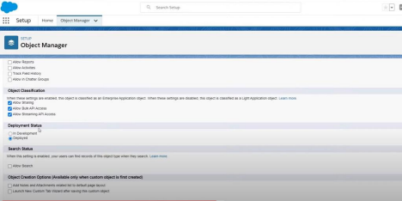

2) Fields and relationships

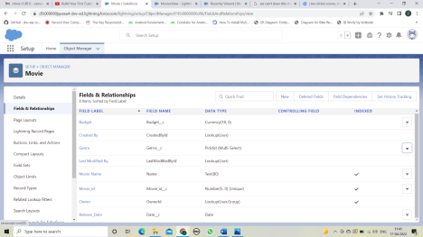

3) App creation

i. App details and branding

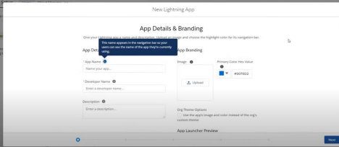

ii. Navigating in App

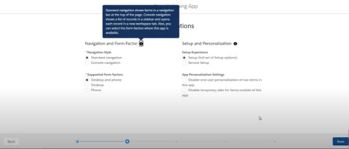

iii. Utility Items

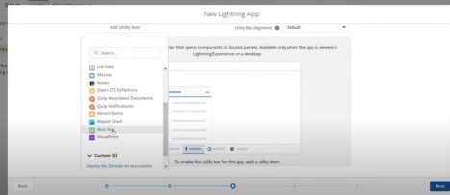

iv. Navigation Items

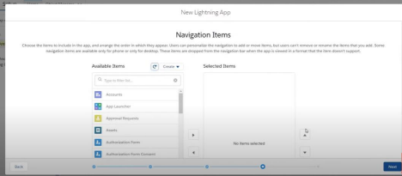

v. User profile

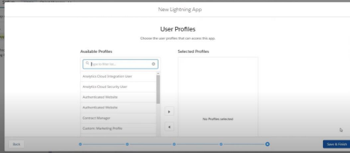

4) Tab creation

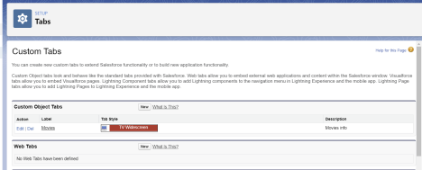

5) Movies object (Split view)

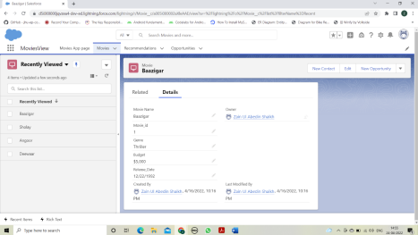

6) Movie app page

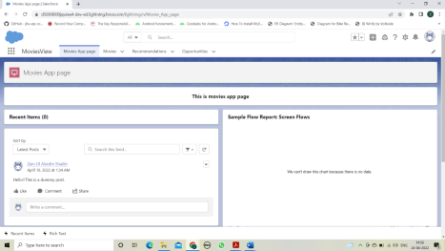

**Conclusion: -**

In this Assignment we have learned the creation of an application on the leading cloud platform Salesforce and implemented the same to build movie application on it.